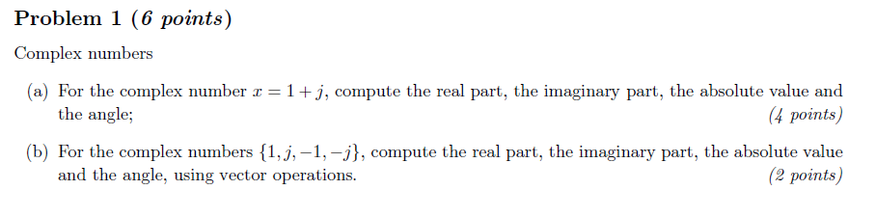

(a)

x=1+1j

a=real(x)

b=imag(x)

c=abs(x)

d=angle(x)

Below are the Matlab outputs from Command Window while invoking the function

x =

1.0000 + 1.0000i

a =

1

b =

1

c =

1.4142

d =

0.7854

(b)

x=[1,1j,-1,-1j]

a=real(x)

b=imag(x)

c=abs(x)

d=angle(x)

Below are the Matlab outputs from Command Window while invoking the function

x =

1.0000 + 0.0000i 0.0000 + 1.0000i -1.0000 + 0.0000i 0.0000 - 1.0000i

a =

1 0 -1 0

b =

0 1 0 -1

c =

1 1 1 1

d =

0 1.5708 3.1416 -1.5708

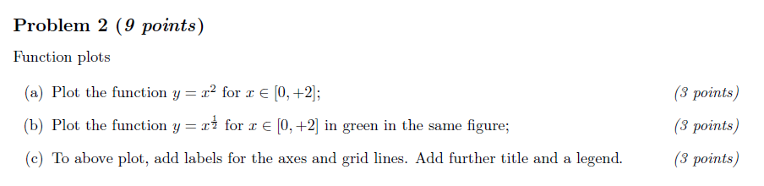

(a)

x1=0:0.1:2

y1=x1.^2

plot(x1,y1)

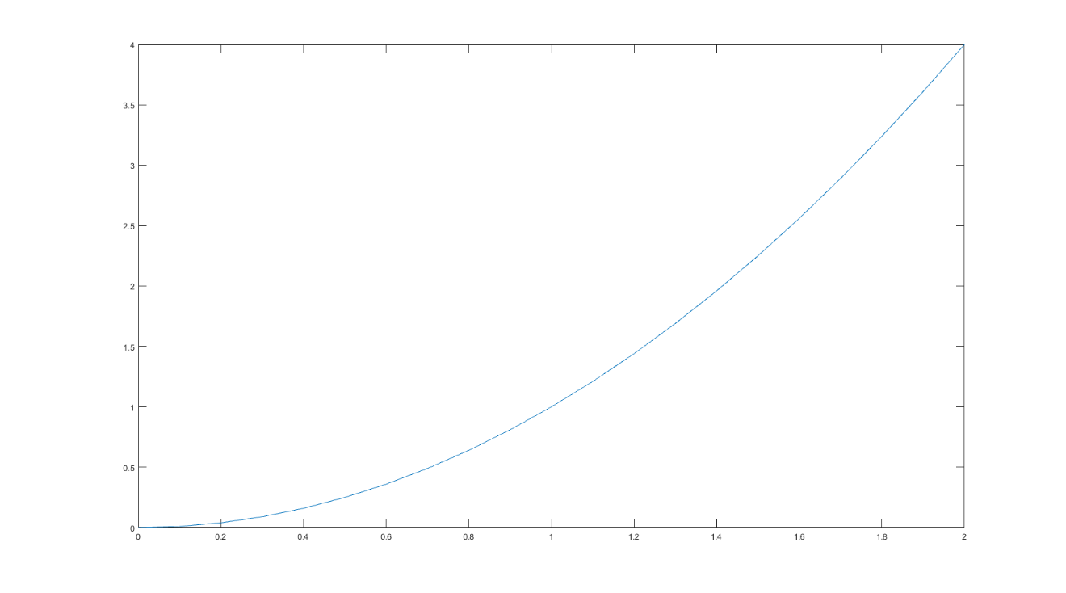

(b)

x1=0:0.1:2

y1=x1.^2

plot(x1,y1)

x2=0:0.05:2

y2=x2.^(1/2)

plot(x1,y1,x2,y2,'g')

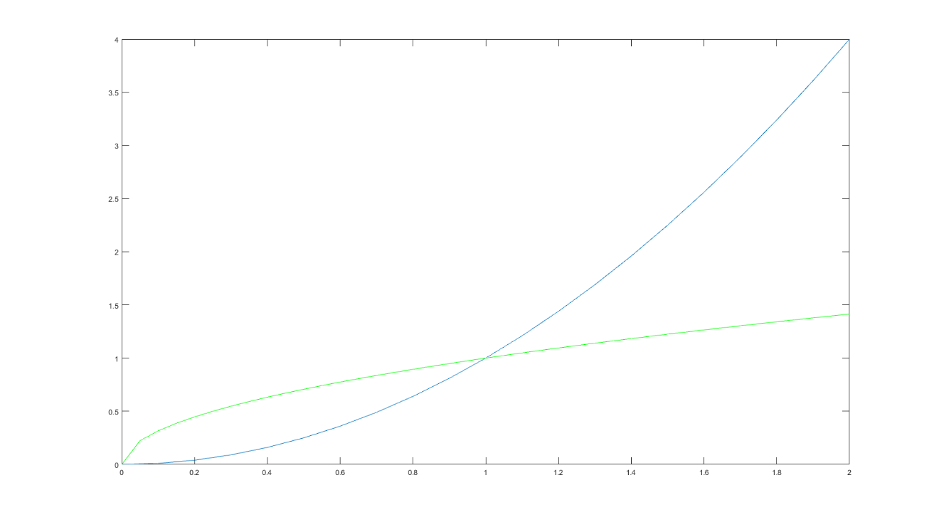

(c)

x1=0:0.1:2

y1=x1.^2

plot(x1,y1)

x2=0:0.05:2

y2=x2.^(1/2)

plot(x1,y1,x2,y2,'g')

xlabel('input')

ylabel('output')

grid on

title('The relationship of input and output')

legend('function of problem(a)','function of problem(b)')

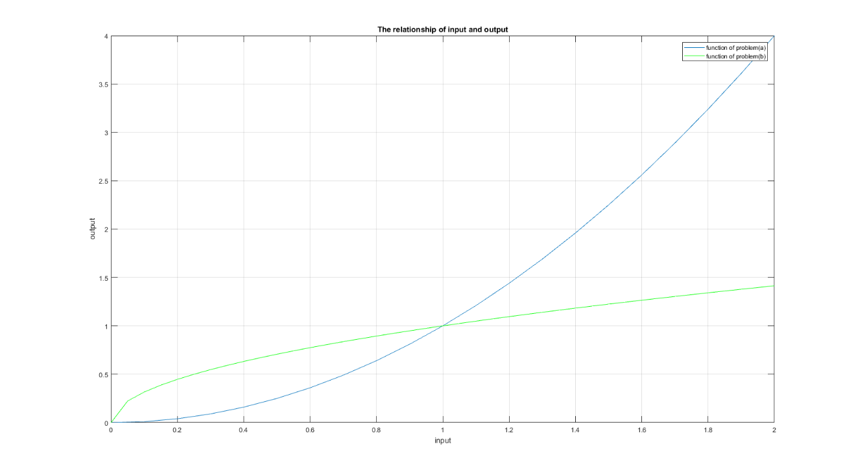

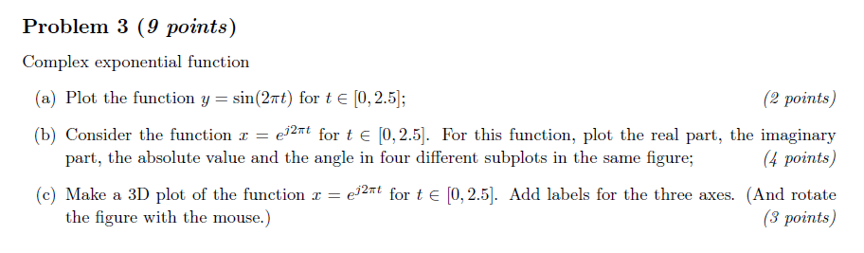

(a)

t=0:0.05:2.5

y=sin(2*pi*t)

plot(t,y)

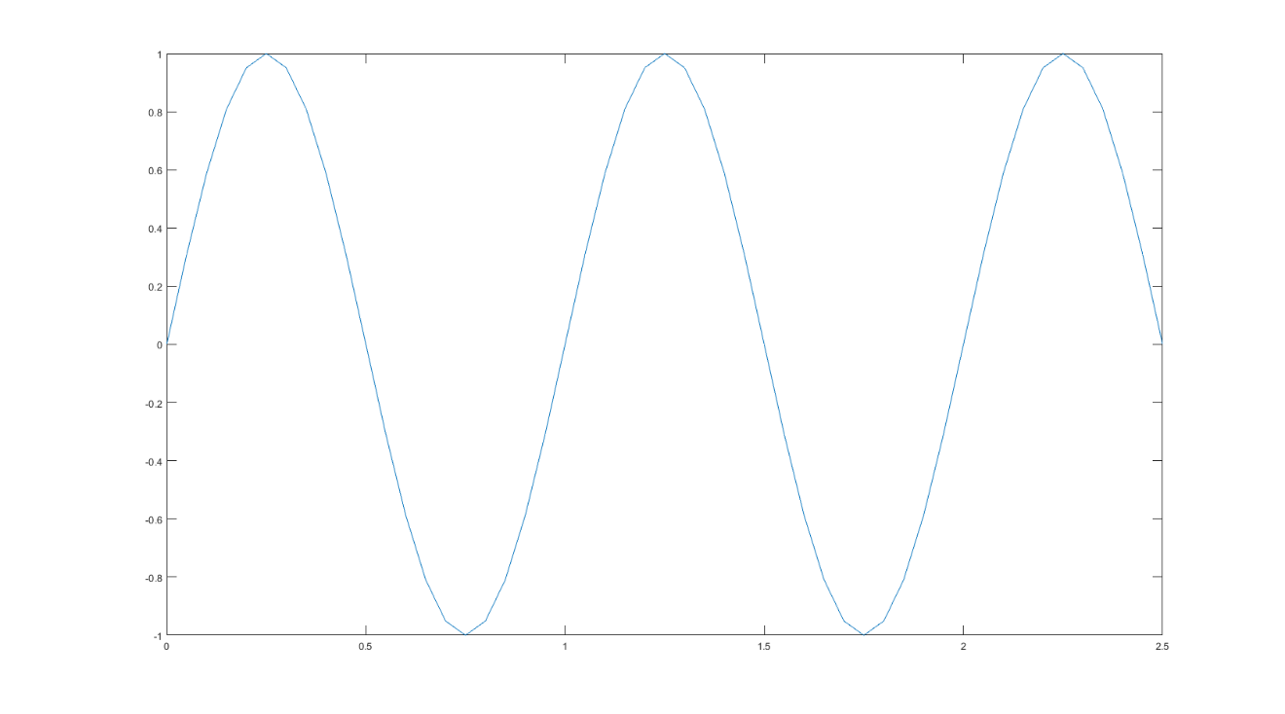

(b)

t=0:0.05:2.5

x=exp(1j*2*pi*t)

subplot(2,2,1)

plot(t,real(x))

grid on

title('The real part')

subplot(2,2,2)

plot(t,imag(x))

grid on

title('The imaginary part')

subplot(2,2,3)

plot(t,abs(x))

grid on

title('The absolute value part')

subplot(2,2,4)

plot(t,angle(x))

grid on

title('The angle part')

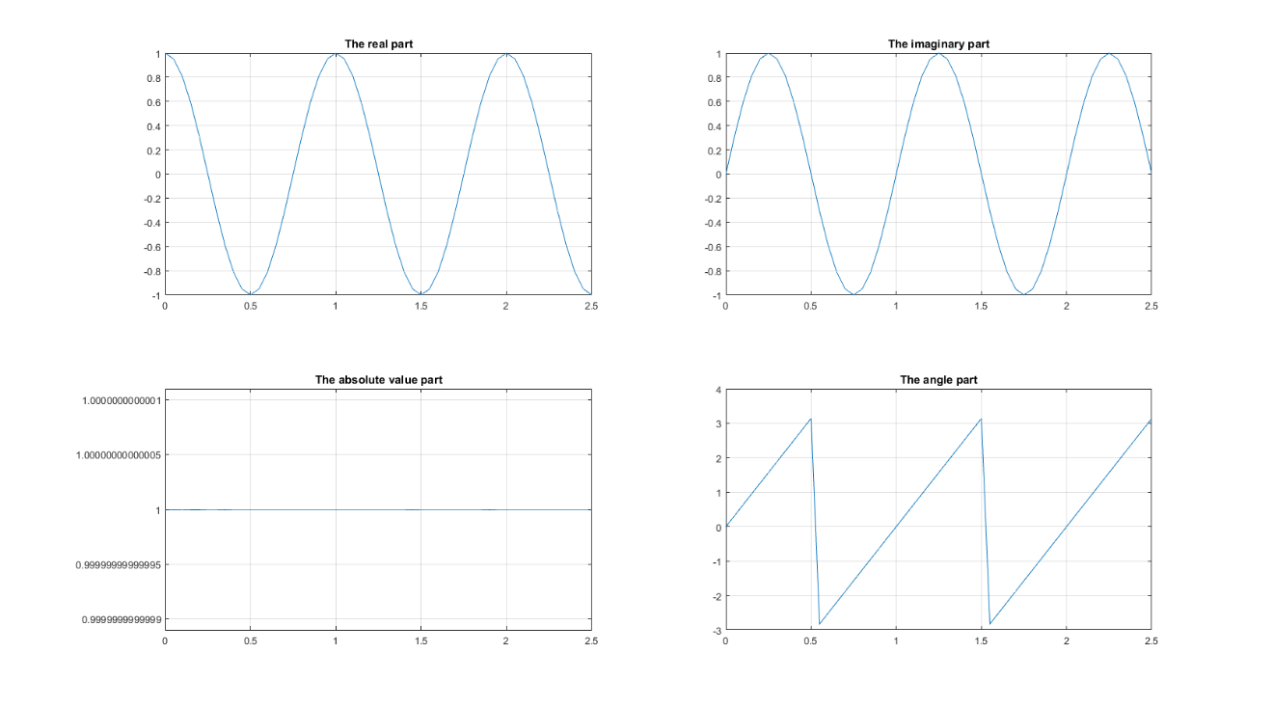

(c)

t=0:0.05:2.5

x=exp(1j*2*pi*t)

plot3(t, real(x),imag(x) )

grid on

rotate3d on

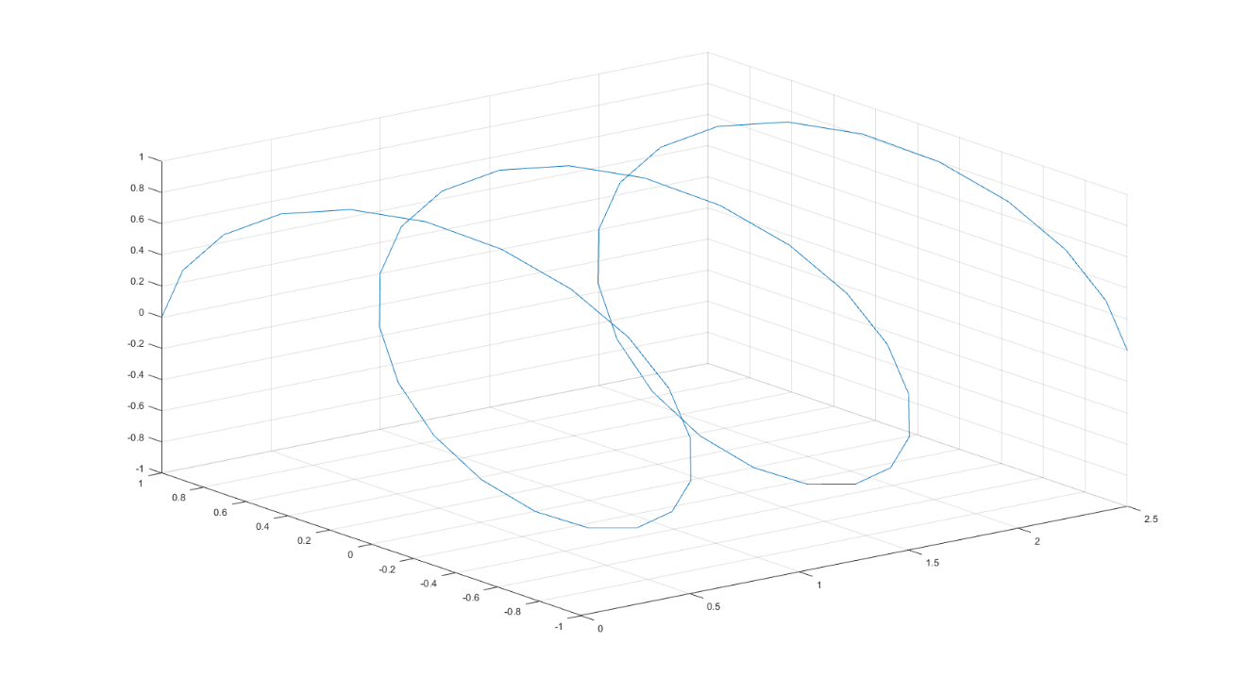

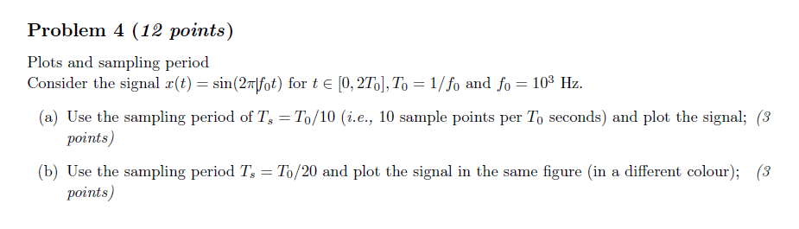

(a)

f01=10^3

T01=1/f01

t1=0:T01/10:2*T01

x_t=2*sin(2*pi*f01*t1)

plot (t1,x_t)

grid on

legend('x_t')

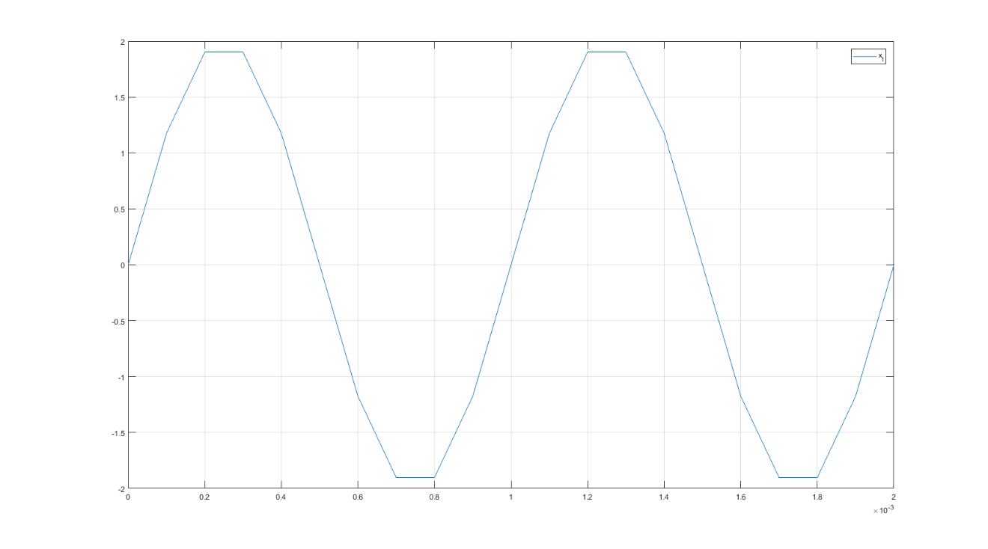

f01=10^3

T01=1/f01

t1=0:T01/10:2*T01

x_t1=sin(2*pi*f01*t1)

f02=10^3

T02=1/f02

t2=0:T02/20:2*T02

x_t2=sin(2*pi*f02*t2)

plot (t1,x_t1,t2,x_t2,'g')

grid on

legend('x_t1','x_t2')

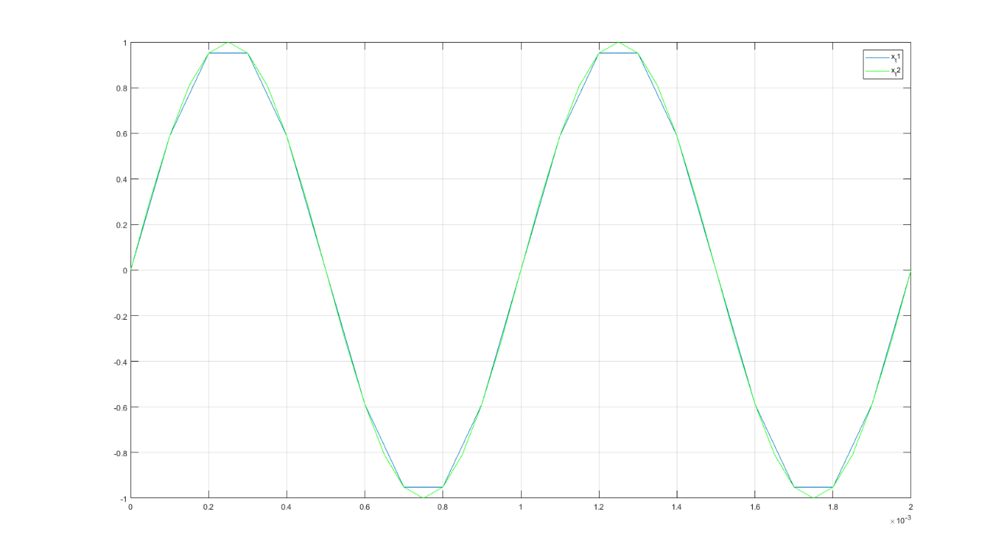

(b)

f01=10^3

T01=1/f01

t1=0:T01/10:2*T01

x_t1=sin(2*pi*f01*t1)

f02=10^3

T02=1/f02

t2=0:T02/20:2*T02

x_t2=sin(2*pi*f02*t2)

f03=10^3

T03=1/f03

t3=0:T03/4:2*T03

x_t3=sin(2*pi*f03*t3)

plot (t1,x_t1,t2,x_t2,t3,x_t3,'g')

grid on

legend('x_t1','x_t2','x_t')

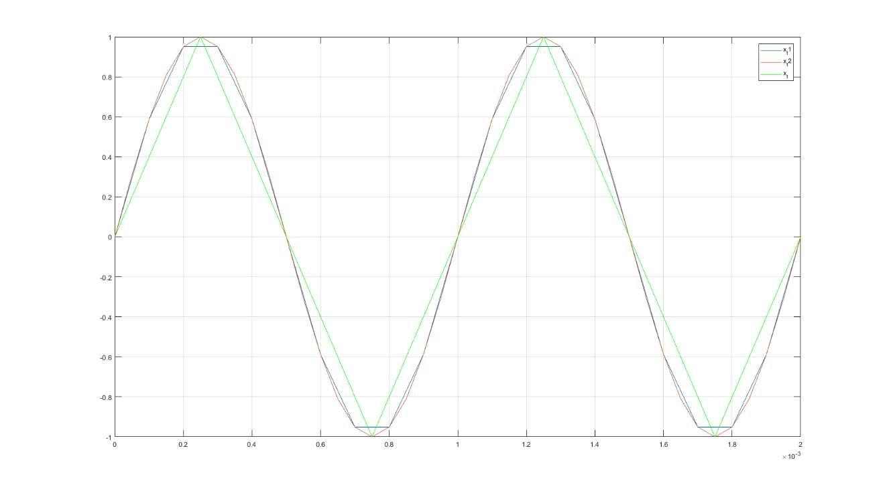

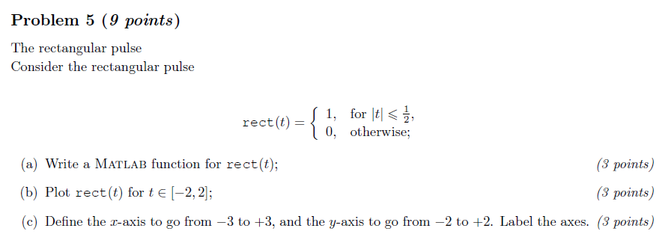

(a)

rect_t=1.*(t>=-0.5 & t<=0.5)

(b)

t=-2:0.001:2;

rect_t=1.*(t>=-0.5 & t<=0.5)

plot(t,rect_t);

grid on

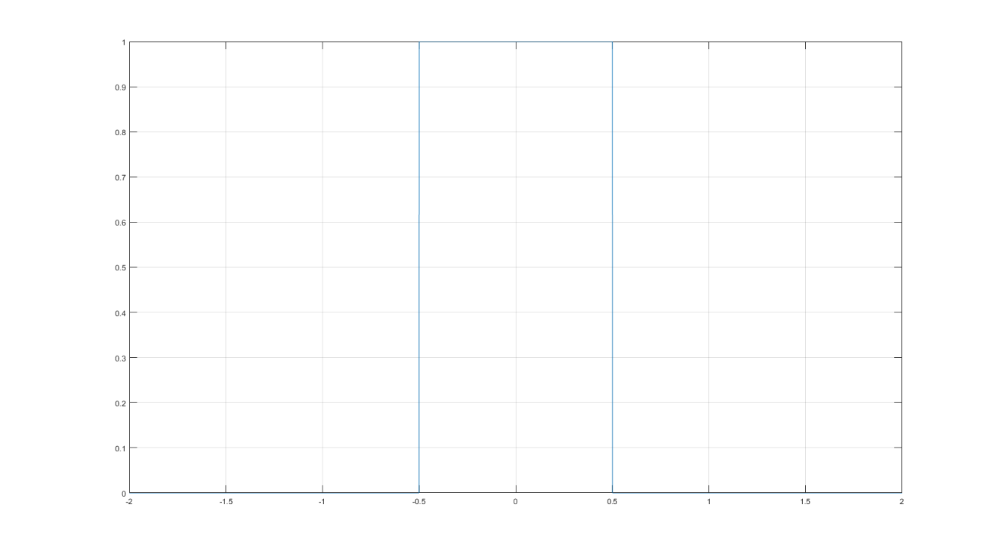

(c)

t=-2:0.001:2;

rect_t=1.*(t>=-0.5 & t<=0.5);

plot(t,rect_t);

axis([-3,3,-2,2])

grid on

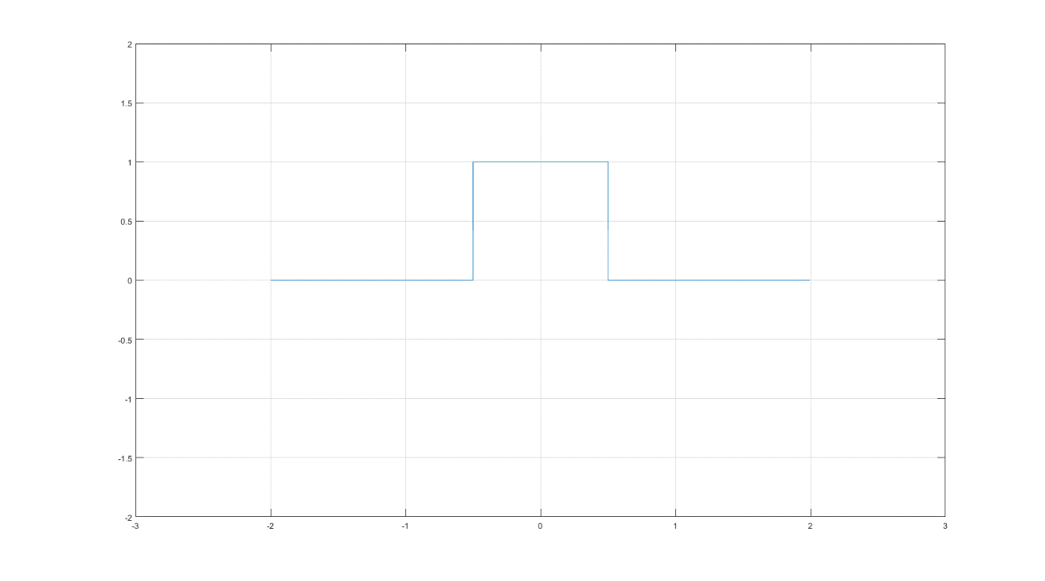

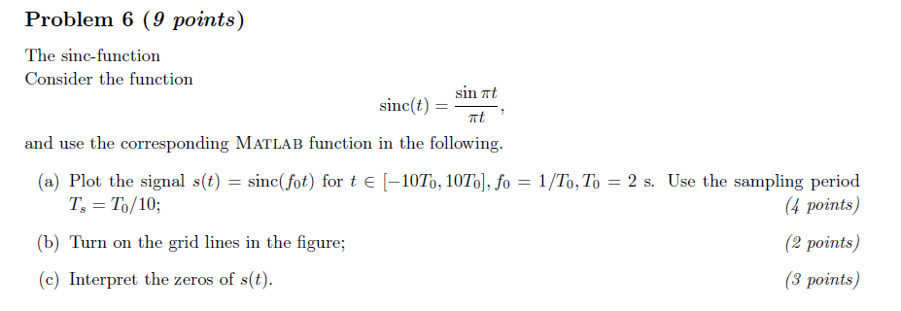

(a)

T0=2

f0=1/T0

t=-10*T0:T0/10:10*T0

y = sinc(f0*t);

plot(t,y);

xlabel('Time (sec)');ylabel('Amplitude'); title('Sinc Function')

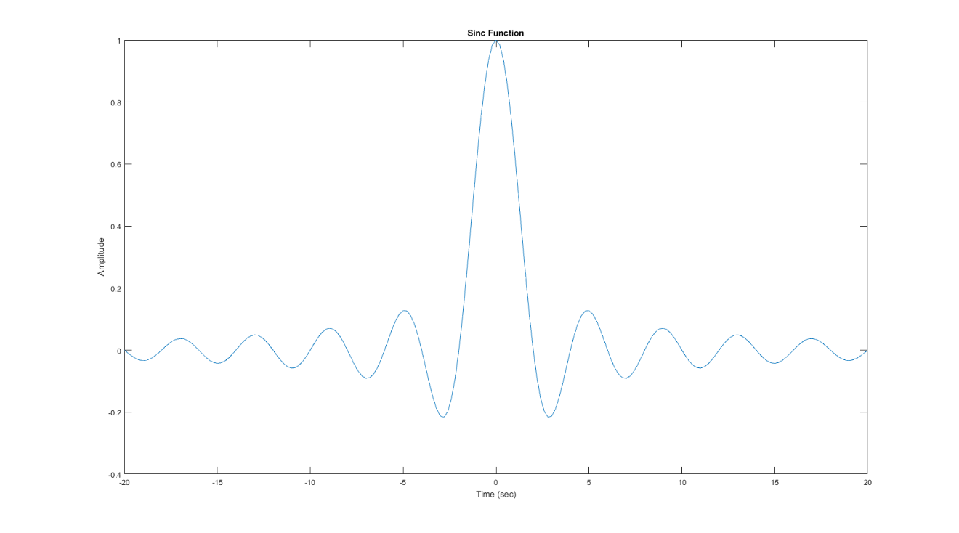

(b)

T0=2

f0=1/T0

t=-10*T0:T0/10:10*T0

y = sinc(f0*t);

plot(t,y);

xlabel('Time (sec)');ylabel('Amplitude'); title('Sinc Function')

grid on

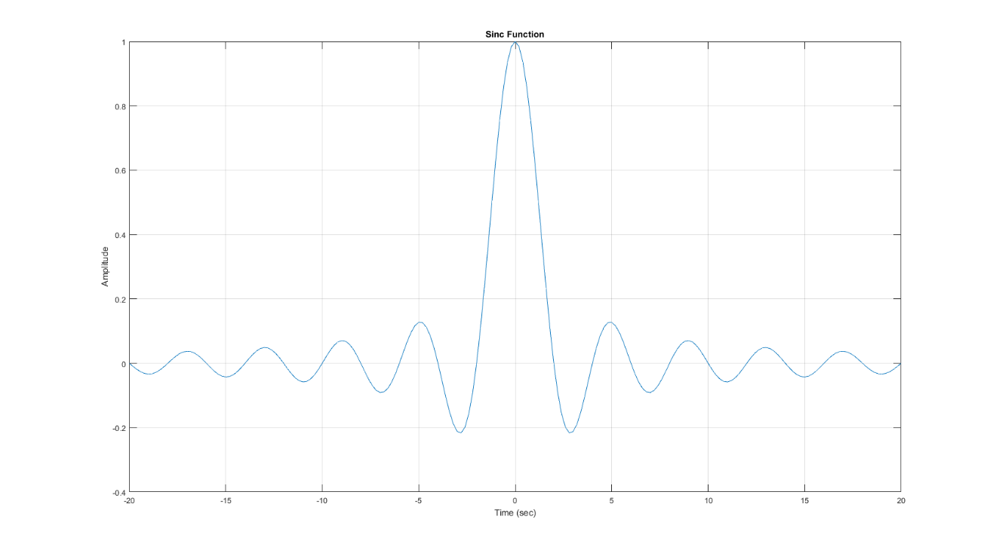

(c)

T0=2;

f0=1/T0;

t=-10*T0:T0/10:10*T0;

y = sinc(f0*t);

f_t=@(t)[sinc(f0*t)];

zeros=fzero(f_t,0)

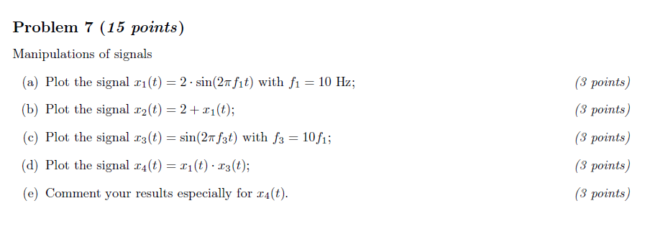

(a)

f1=10

t=-0.5:0.001:0.5

x_t1=2*sin(2*pi*f1*t)

plot (t,x_t1)

grid on

legend('x_t1')

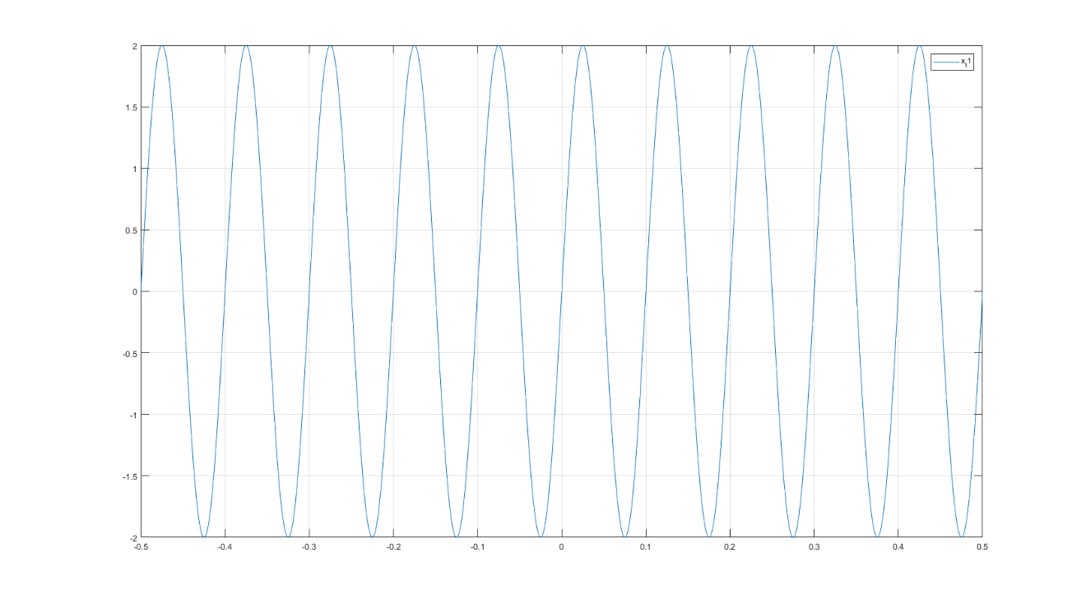

(b)

f1=10

t=-0.5:0.001:0.5

x_t1=2*sin(2*pi*f1*t)

x_t2=2+x_t1

plot (t,x_t2)

grid on

legend('x_t2')

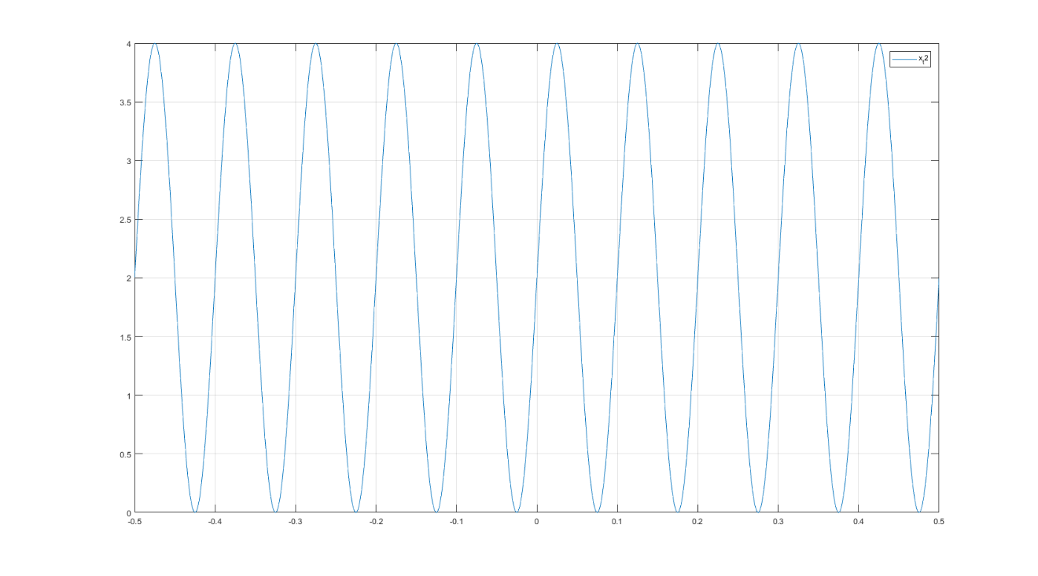

(c)

f1=10

f3=10*f1

t=-0.5:0.001:0.5

x_t3=2*sin(2*pi*f3*t)

plot (t,x_t3)

grid on

legend('x_t3')

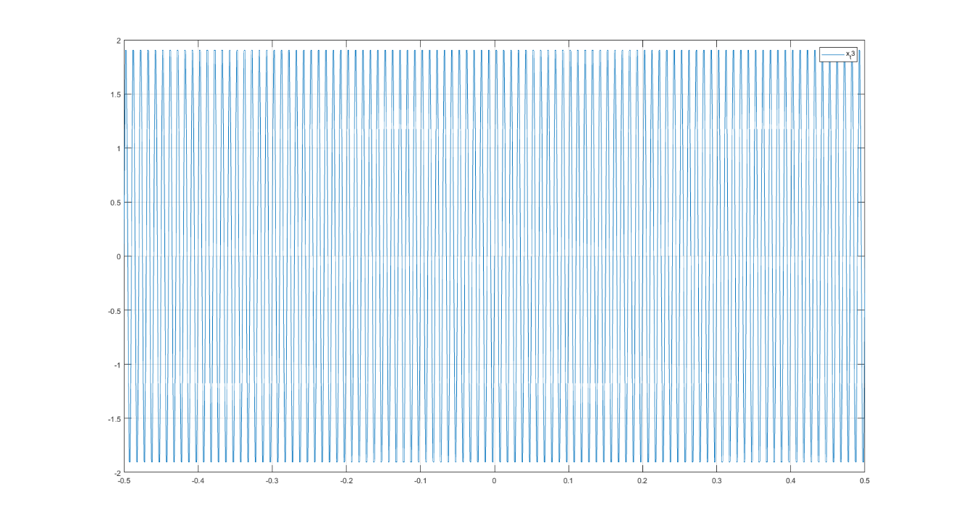

(d)

f1=10

f3=10*f1

t=-0.5:0.001:0.5

x_t1=2*sin(2*pi*f1*t)

x_t3=2*sin(2*pi*f3*t)

x_t4=(x_t1).*(x_t3)

plot (t,x_t4)

grid on

legend('x_t4')

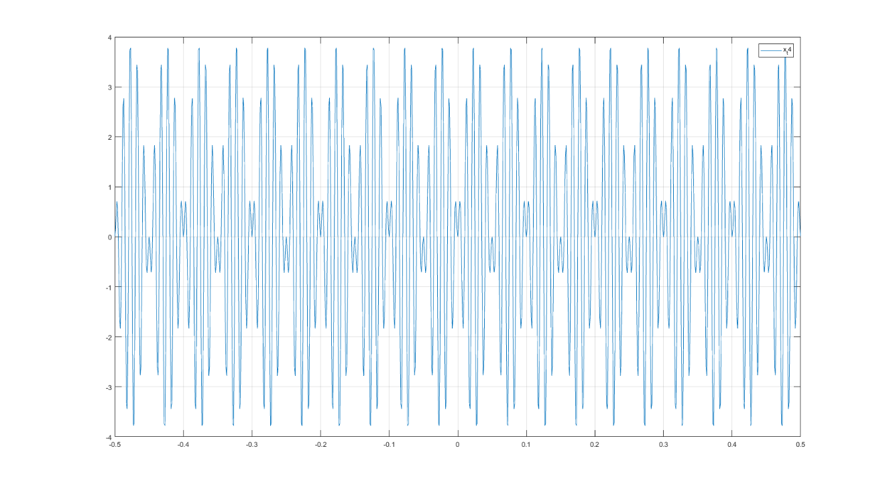

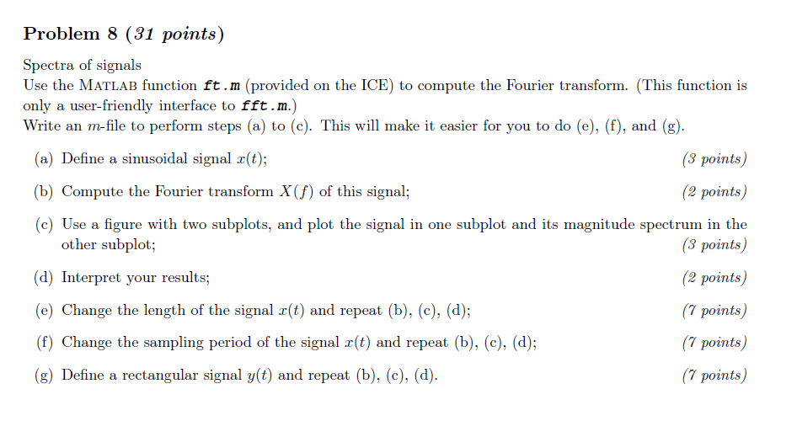

(a)(b)(c)

t=-10:0.01:10

x_t=sin(t)

[f,S] = ft(t,x_t)

subplot(1,2,1)

plot(t,x_t)

grid on

title('signal')

subplot(1,2,2)

plot(f,S)

grid on

title('magnitude spectrum')

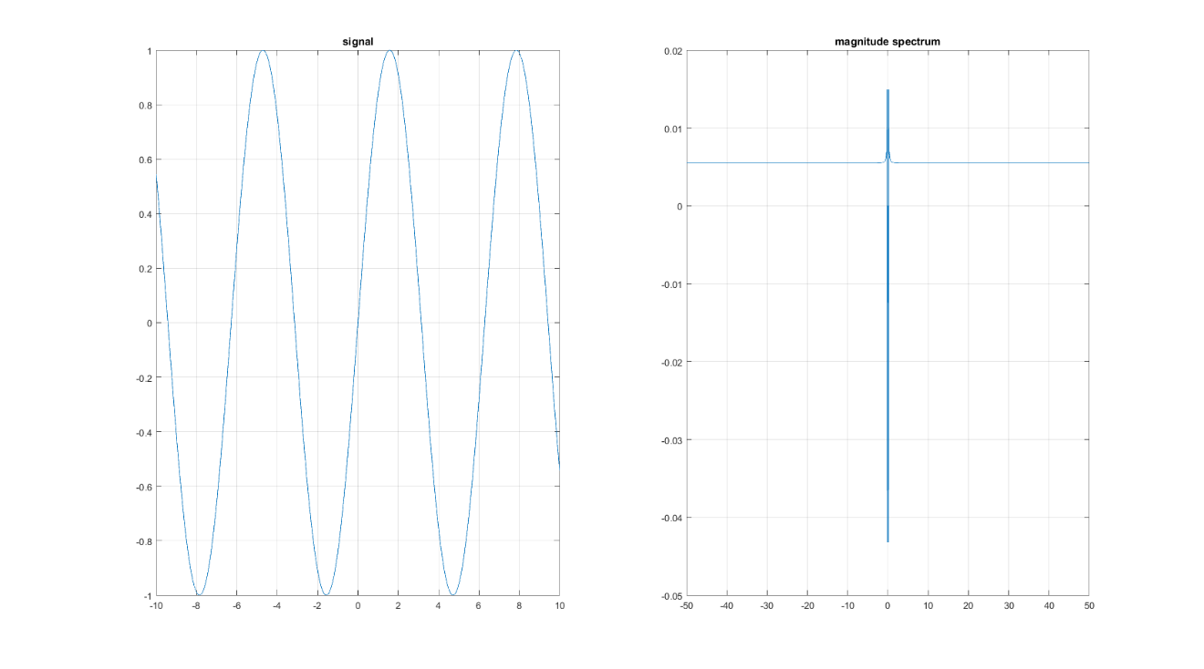

(d)

(e) t=-1:0.01:1

t=-1:0.01:1

x_t=sin(t)

[f,S] = ft(t,x_t)

subplot(1,2,1)

plot(t,x_t)

grid on

title('signal')

subplot(1,2,2)

plot(f,S)

grid on

title('magnitude spectrum')

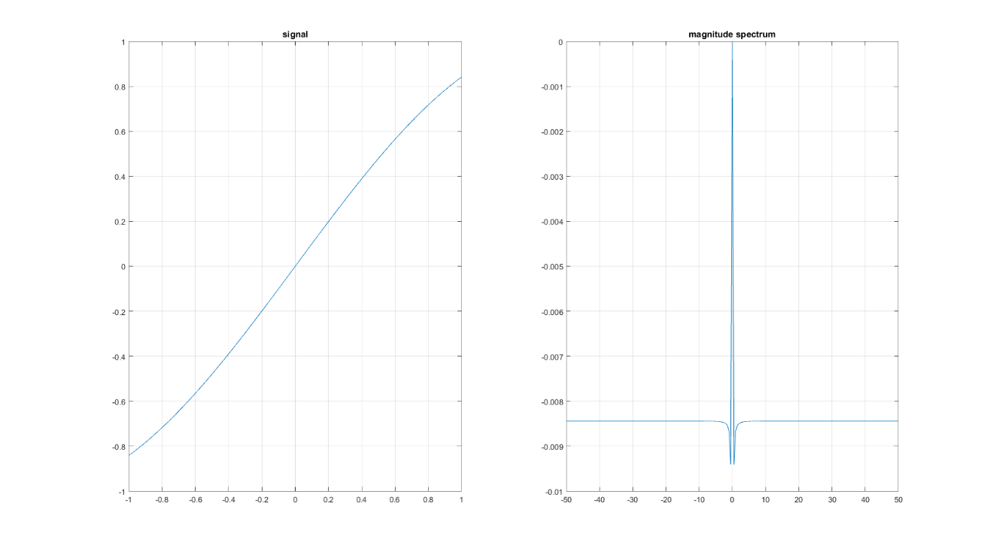

t=-5:0.01:5

t=-5:0.01:5

x_t=sin(t)

[f,S] = ft(t,x_t)

subplot(2,2,1)

plot(t,x_t)

grid on

title('signal')

subplot(2,2,2)

plot(f,S)

grid on

title('magnitude spectrum')

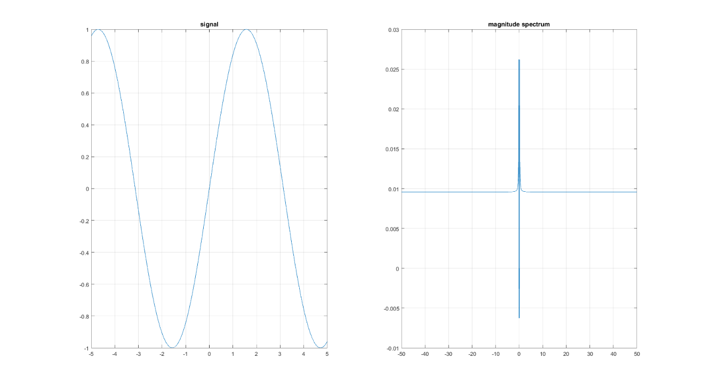

(f) sampling period=0.001

t=-10:0.001:10

x_t=sin(t)

[f,S] = ft(t,x_t)

subplot(1,2,1)

plot(t,x_t)

grid on

title('signal')

subplot(1,2,2)

plot(f,S)

grid on

title('magnitude spectrum')

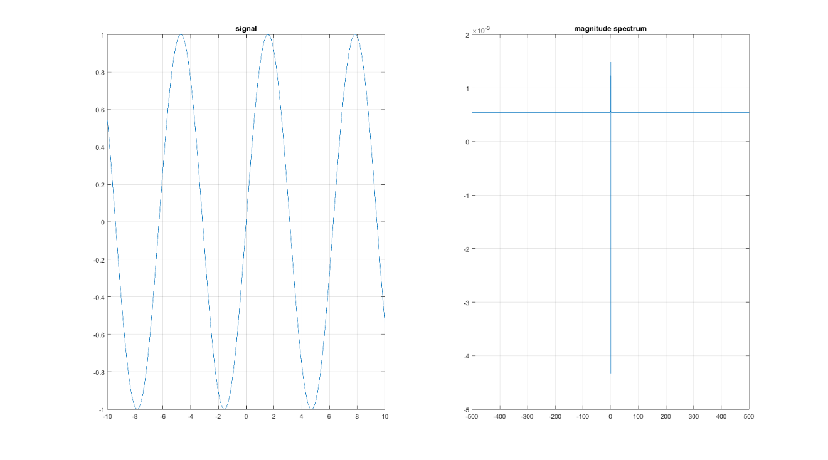

sampling period=0.1

t=-10:0.1:10

x_t=sin(t)

[f,S] = ft(t,x_t)

subplot(1,2,1)

plot(t,x_t)

grid on

title('signal')

subplot(1,2,2)

plot(f,S)

grid on

title('magnitude spectrum')

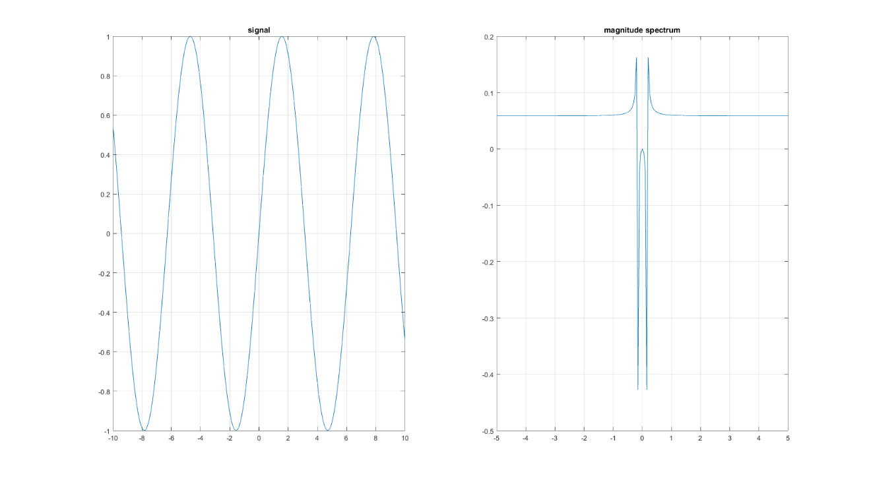

(g) sampling period=0.01

t=-10:0.01:10

rect_t=1.*(t>=-0.5 & t<=0.5)

[f,S] = ft(t,rect_t)

subplot(1,2,1)

plot(t,rect_t)

grid on

title('signal')

subplot(1,2,2)

plot(f,S)

grid on

title('magnitude spectrum')

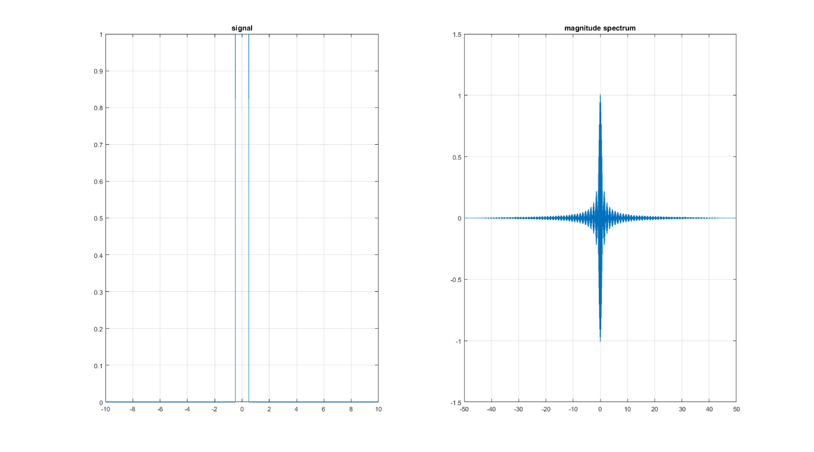

sampling period=0.001

t=-10:0.001:10

rect_t=1.*(t>=-0.5 & t<=0.5)

[f,S] = ft(t,rect_t)

subplot(1,2,1)

plot(t,rect_t)

grid on

title('signal')

subplot(1,2,2)

plot(f,S)

grid on

title('magnitude spectrum')

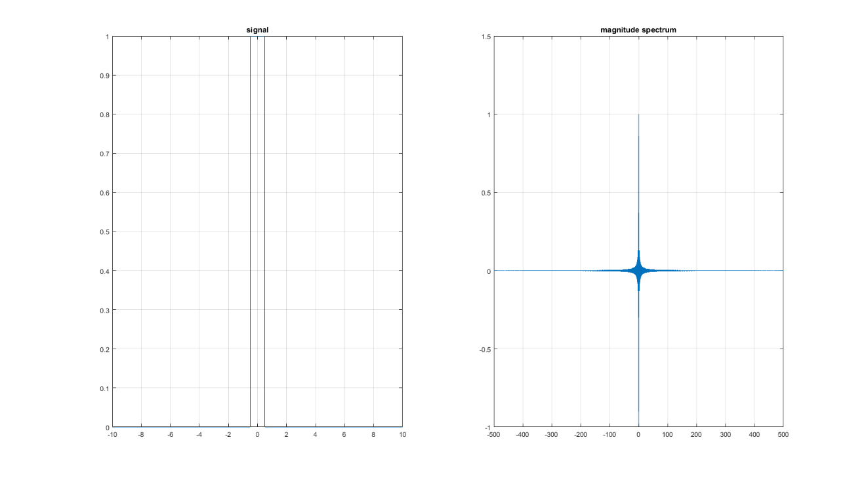

sampling period=0.1

t=-10:0.1:10

rect_t=1.*(t>=-0.5 & t<=0.5)

[f,S] = ft(t,rect_t)

subplot(1,2,1)

plot(t,rect_t)

grid on

title('signal')

subplot(1,2,2)

plot(f,S)

grid on

title('magnitude spectrum')

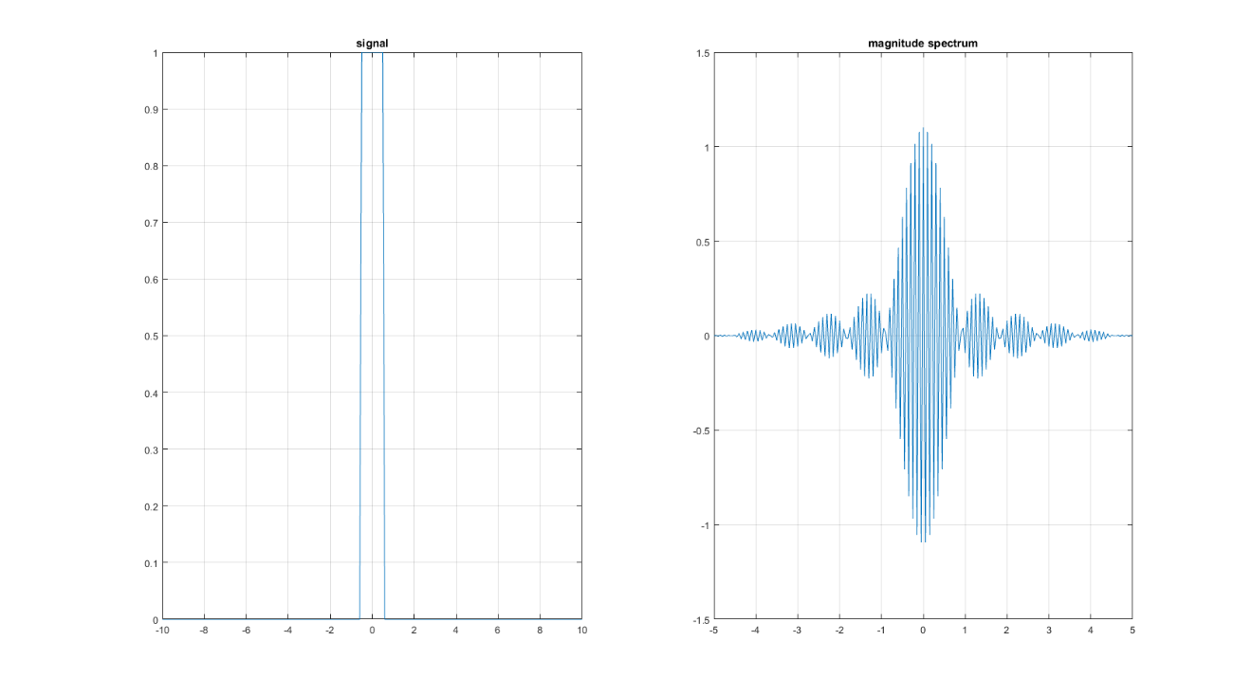

t=-1:0.01:1

t=-1:0.01:1

rect_t=1.*(t>=-0.5 & t<=0.5)

[f,S] = ft(t,rect_t)

subplot(1,2,1)

plot(t,rect_t)

grid on

title('signal')

subplot(1,2,2)

plot(f,S)

grid on

title('magnitude spectrum')

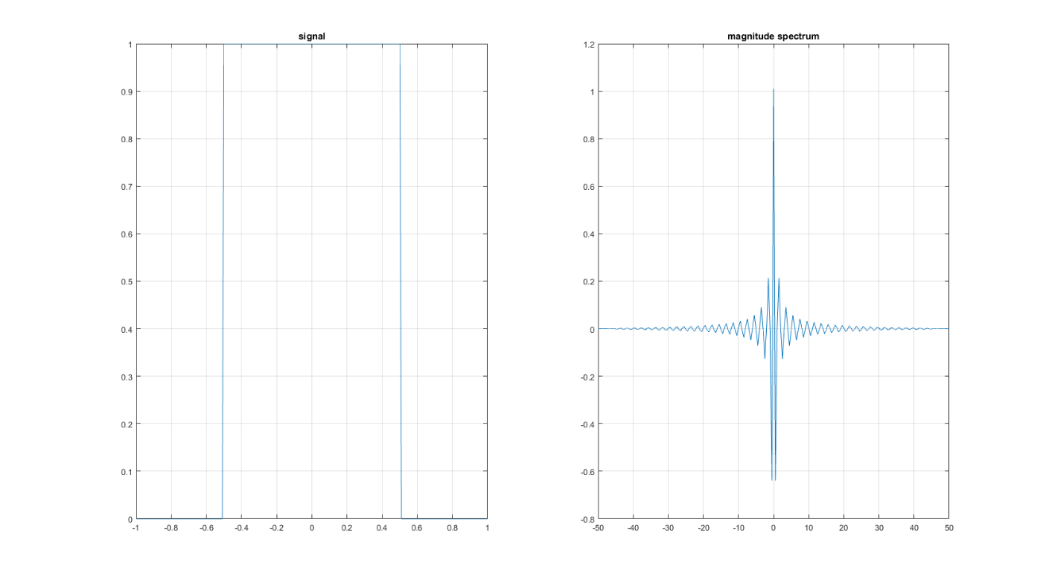

t=-5:0.01:5

t=-5:0.01:5

rect_t=1.*(t>=-0.5 & t<=0.5)

[f,S] = ft(t,rect_t)

subplot(1,2,1)

plot(t,rect_t)

grid on

title('signal')

subplot(1,2,2)

plot(f,S)

grid on

title('magnitude spectrum')

